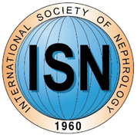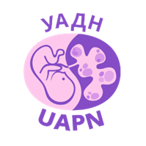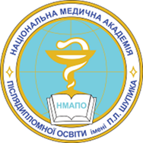

COURSE SIMPOZIUM PROGRAM
Annual REENA ™ (Renal Eastern Europe Nephrology Academy) CME Course (Since 2006)
PEDIATRIC CASE OF RARE KIDNEY DISEASE: ONSET, MANAGEMENT, FOLLOW-UP
PERSONALIZED NEPHROLOGY: CKD UNTIL CKD5T: FROM CHILDHOOD TO ADULTS
14.09.2018
Kiev-Irpen
10.00-12.00
Pediatric Rare Kidney Disease. Is it really rare?
Dmytro Ivanov, UAPN President, MD, Prof, Head of Nephrology and RRT Dep P.L.Shupyk National Medical Academy of Postgraduate Education, Kiev, Ukraine)
Tuberous sclerosis complex. 10 years management in Ukraine
Stella V.Kushirenko, MD, PhD. Ass Prof Dean P.L.Shupyk National Medical Academy of Postgraduate Education, Kiev, Ukraine
Light chain disease, proteomics and pathomorhology links in rare kidney disease
Olena A. Dyadyk, MD, Prof. Head of Pathology and Topographic Anatomy Dep P.L.Shupyk National Medical Academy of Postgraduate Education, Kiev, Ukraine, Mariia Ivanova, MD, PhD, Milano Bicocca University, Italy

Features of kidneys morphology of fetuses and newborns developing in conditions of maternal preeclampsia
M.S. Myroshnychenko, MD, Ass Prof, I.V. Sorokina, MD, Prof, M.D. Ivanova, PhD
Kharkiv National Medical University, Kharkiv, Ukraine, Bogomolets National Medical University, Kyiv, Ukraine, University Milan-Bicocca, Milan, Italy

Nephrogenic genesis of preeclampsia development and its early predictors
Volodymyr V. Artyomenko, MD, PhD, DSc, Prof, Liudmyla I.Berlinska, MD, Department of Obstetrics and Gynecology № 2, Odessa National Medical University, Odessa, Ukraine.
Discussion

12.30-13.30 Urinary tract infections (industrial symposium)
14.00-15.00 New approach in renoprotection and blood pressure control (industrial symposium)

