

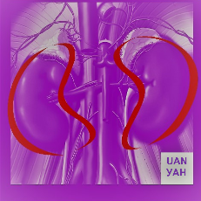
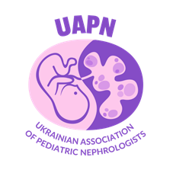
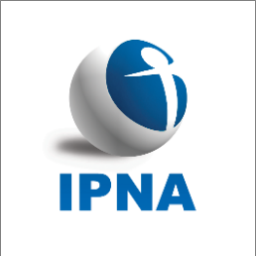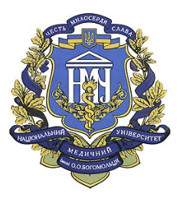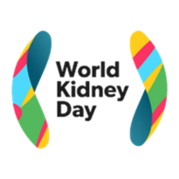

COURSE PROGRAM
STICK TO TOP TIPS in order to maintain kidney health
CME hybrid (live and synchronous online access) Course
Ukraine Kyiv September 19-20, 2024
Managed by UAN, UAPN

Location: Nephrology clinic (Kyiv, V.Vasilkivska, 29b)
Format: hybrid
September 19, 2023 Tuesday
8.45 Opening CME course
9.00-11.00 Clinical Guidelines in order to manage CKD
9.00-9.30. Volodymyr V. Bezruk, MD, MD, Prof., (IPNA member) KDIGO CKD (2024). Bukovinian State Medical University, Chernivtsi, Ukraine
9.30.-10.00 Dmytro D. Ivanov, MD, Prof., (IPNA member) KDIGO update PKD (2024). Bogomolets National Medical University, Kyiv, Ukraine
10.00-11.00 Special topic. Paul Goodyer, MD, Prof (IPNA speaker) COVID vaccine mRNA technology to treat genetic kidney disease. Professor of Pediatrics and Human Genetics, McGill University Health Centre, Montreal, QC, Canada (with on-line translation)
11.00-11.30 Break
11.30-13.30 Manage your practical skills
11.30-12.15 Francesco Emma, MD, Prof (IPNA speaker) Guidelines for X-linked hypophosphatemic rickets. UOC di Nefrologia, Ospedale Pediatrico Bambino Gesù, Rome, Italy (with translation)
12.15-13.00 Lutz T. Weber, MD, Prof (IPNA speaker) Management of Idiopathic Nephrotic Syndrome in Childhood - The German Guideline and a critical review. Chairman of the German Society for Pediatric Nephrology, Berlin, Germany (with translation)
13.00-13.30 Liudmyla I. Vakulenko, MD, Prof. (IPNA member) Treatment of phosphate-diabetes: practical approach. Head of the Department of Propaedeutics of Children's Diseases and Pediatrics 2 of the Dnipro State Medical University
13.30-14.00 Break
14.00-16.00 Treatment of Nephrotic syndrome
14.00-14.45 Eugene Yu-hin Chan, MD, Prof (IPNA speaker) Rituximab use in SRNS in children. Paediatric Nephrology Centre, Hong Kong Children's Hospital, Hong Kong (with translation)
14.45-15.30 Paul Goodyer, MD, Prof (IPNA speaker) A new monoclonal therapy for nephrotic syndrome. Professor of Pediatrics and Human Genetics, McGill University Health Centre, Montreal, QC, Canada (with translation)
15.30-16.00 Elizaveta K. Lagodych, MD. Rituximab in treatment of NS. Bogomolets National Medical University, Department of Nephrology and Urology, Kyiv, Ukraine
16.00-16.30 Break
16.30-17.30 Practical tips
16.30-17.00. Dmytro V. Shevchuk, MD, PhD, Ass. Prof, Maksym Ovechko, MD, Yulia Kislova, MD, Liliya Hrytskiv, MD. Biopsy of a transplanted kidney: pros/cons. 1st Territorial Medical Association, Lviv, Ukraine
17.00-17.45 Francesco Emma, MD, Prof (IPNA speaker) C3 nephropathy. UOC di Nefrologia, Ospedale Pediatrico Bambino Gesù, Rome, Italy (with translation)
17.45-18.15 Mariia D. Ivanova, MD, PhD Digital approach in kidney biopsy. Instituto Europeo di Oncologia-IEO, Milan, Italy
18.15-19.00 Take home message. CME Tests. Discussion, final comments of the day

September, 20, 2024, Friday
8.55 CME course is due
9.00-12.00 Clinical Guidelines in CKD practical management
9.00-9.30. Liudmyla I. Vakulenko, MD, Prof. (IPNA member) KDIGO 2024 clinical practice guideline for the management of lupus nephritis. Head of the Department of Propaedeutics of Children's Diseases and Pediatrics 2 of the Dnipro State Medical University
9.30.-10.00 Volodymyr V. Bezruk, MD, MD, Prof., (IPNA member) Rehabilitation in post emergency zones: modern approach to rehabilitation resulting war in Ukraine. Bukovinian State Medical University, Chernivtsi, Ukraine
10.00-10.30 Olga I. Chub, MD, PhD, associate Prof. Impact of war on CKD development and progression among people, living in war-affected region (Kharkiv): first results of Save Kidneys Study. Clinical Research Program ISN. Dep. of Therapy, Nephrology and Cardiology, Kharkiv National Medical University, Ukraine
10.30-11.00 Dmytro D. Ivanov, MD, Prof., (IPNA member) Green Nephrology and Ecoreality: implementation of Green Nephrology, Bogomolets National Medical University, Kyiv, Ukraine
12.00-12.30 Break
12.30-14.30 Manage your practical skills
12.30-13.15 Rukshana Shroff, MD, Prof (IPNA speaker) Practical tips on PD in children. Professor of Paediatric Nephrology and Dialysis, UCL Great Ormond Street Hospital for Children and Institute of Child Health, London, GB (with translation)
13.15-13.45 Oleg Nezhurin. Individualization of dialysis. President of the Association of Hemodialysis Patients
13.45-14.15 Olena Karpenko, Doctor of Medicine, Department of Nephrology and Urology of O.O. Bogomolets National Medical University, Kyiv, Ukraine Kyiv City Center of Nephrology and Dialysis, Kyiv, Ukraine
14.15-14.30 Olga O. Dobrik, MD, PhD. Vit D deficits. Lviv, Ukraine
14.30-15.00 Break
15.00-16.30 Treatment tips presented by experts
15.00-15.15 Incremental dialysis. Iryna M. Zavalna, MD, Kyiv, Ukraine
15.15-15.30 AV fistula. Yusuf Sonmez, MD, Istambul, Turkey
15.30.-15.45 PKD Iryna V. Krasyk, MD, PhD, Ass. Prof., Kyiv, Ukraine
15.45-16.00 IgAN. Olga I Chub, MD, PhD, Ass. Prof. New therapeutic approach in the treatment of IgA nephropathy: focus on pathophysiology. Dep. of Therapy, Nephrology and Cardiology, Kharkiv National Medical University, Ukraine
16.00-16.15. CKD (local expert)
16.15-16.30. AKI (local expert)
16.30-17.00 Round table
17.00-17.15.
17.15-17.30
17.30-17.45
17.45-18.00
18.00-18.30 Take home message. CME Tests. Discussion, final comments

